Name of Student: Husam Ali Abdalla Nour | PRN:25070122086
Semester: III | Year : AY 2026-27
Subject: Programming with Java
ASSIGNMENT No : 10
TITLE : Abstract Classes and Methods

Problem Statement
Write a Java program to demonstrate the use of abstract classes and abstract methods
abstract class Shape
{ abstract void draw(); void message()
{
System.out.println("this a shape. "); }
}
class Circle extends Shape
{
void draw()
{
System.out.println("drawing a cercle ");
} }
public class AbstractExample
{ public static void main(String[] args)
{
Shape s= new Circle(); s.draw();
s.message();
}
}

Learning Objectives
To implement abstraction using abstract classes and abstract methods.
Programme

Output
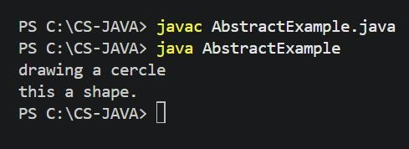

Conclusion
In conclusion, an abstract class is an incomplete class that is used as a base class for other classes. An abstract method is a method without a body, and the child class must provide its implementation. Abstract classes can also contain normal methods with complete implementations. We cannot create an object directly from an abstract class. They are useful when we want to provide a common structure to different child classes while allowing each child to define its own behavior.

